**Summary of Univariate Analysis**

**Result: -**

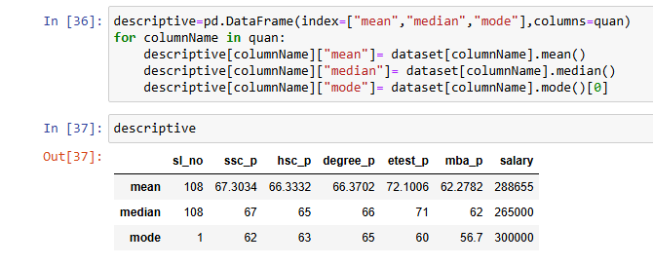

**Description:**

* In **univariate analysis**, the **mean** is the **average** of a single numerical variable. It is calculated by summing all the values in a dataset and dividing by the total number of observations.
* **Mean (Average):** Represents the central tendency of the dataset. For example, the **average salary** is **288,655**, and the **average SSC percentage** is **67.30%**.
* In **univariate analysis**, the **median** is the **middle value** when the data is arranged in **ascending order**. It is a measure of **central tendency** that is less sensitive to outliers compared to the **mean**.
* **Median (Middle Value):** The midpoint of the dataset when sorted. For instance, the **median salary** is **265,000**, indicating half of the salaries are below and half are above this value.
* In **univariate analysis**, the **mode** is the most frequently occurring value in a dataset. It represents the **highest frequency** in a distribution and is useful for understanding **common trends** in data.
* **Mode (Most Frequent Value):** The most commonly occurring value in the dataset. for example the **most frequent salary** is **300,000**.